43.37: a) We need to know how many decays per second occur.
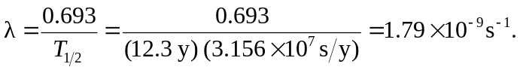
The number of tritium atoms is 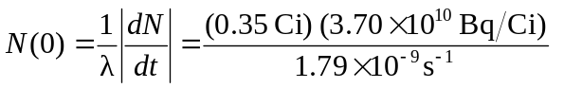
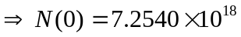nuclei. The number of remaining nuclei after one week is just nuclei So the energy absorbed is So the absorbed dose is 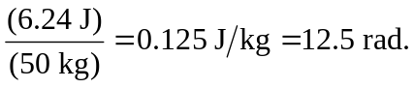 Since RBE = 1, then the equivalent dose is
12.5 rem.
b) In the decay, antinentrinos are also emitted. These are not absorbed by the body, and so some of the energy of the decay is lost (about 12 

